Focus Questions
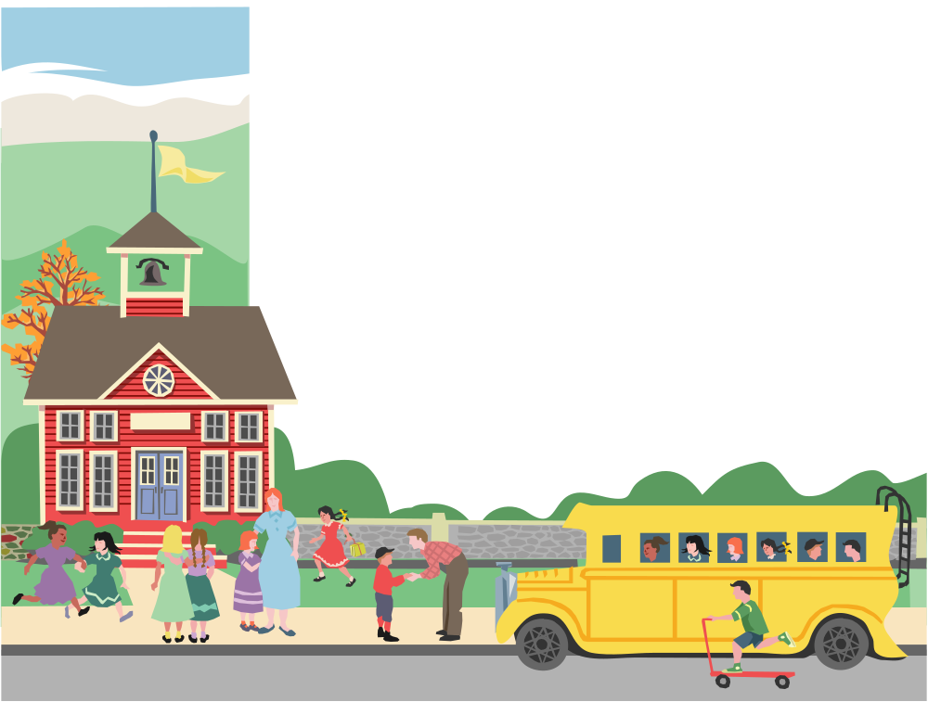

K – 5

for OCR 2000

Kindergarten
 THEME: School

Selection Title | Focus Question(s)
Boomer Goes to School | Why is Boomer confused when he is at school? How does Boomer’s behavior change at the end of the story?
I Brought a Worm | Why is bringing a worm for share time unusual? Why did she eat the worm in front of her class?

 THEME: Shadows

Selection Title | Focus Question(s)
Shadows | What is a shadow? Why does a shadow change size?
The Wolf and His Shadow | Why did the wolf call himself king? Why did the lion think the wolf was silly?
My Shadow | What is a shadow? How does the boy have fun with his shadow?
Bear Shadow | Why does Bear talk to his shadow? Did the shadow finally listen to Bear?

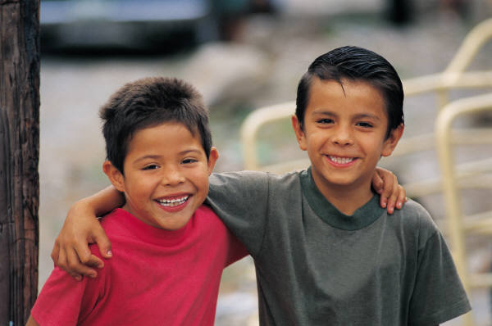 THEME: Finding Friends

Selection Title | Focus Question(s)
The Lonely Prince | Why did the prince feel so sad? How do his parents try to cheer him up?
Making Friends | Why did the boy make faces at the girl? How did the girl feel about his faces?

 THEME: The Wind

Selection Title | Focus Question(s)
Gilberto and the Wind | How is the wind good and bad? How does the wind play with Gilberto?
The Wind | Can you see the wind? How does the wind sing?
What Happens When Wind Blows? | How can the wind change? Why is the wind important to us?

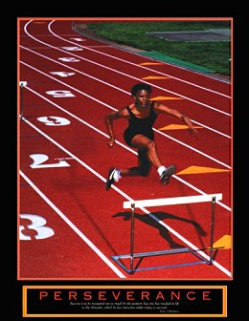 THEME: Stick to It

Selection Title | Focus Question(s)
The Great Big Enormous Turnip | Why does the old man need help? How did everyone work together in this story?
To Catch a Fish | How can a fish be caught? Why is waiting important in fishing?
Tillie and the Wall | Why did Tillie want to climb the wall? How did the mice on the other side react to Tillie?

1st Grade

 THEME: Let’s Read

Selection Title | Focus Question(s)
The Purple Cow | What does a cow look like? Have you ever seen a purple cow?
Las Hormiguitas | What is an ant? Where have you seen ants? What does a group of ants look like when they move together?
If I Were a Mouse | In what ways would your life be different if you were a mouse? In what ways would your life be the same if you were a mouse?
Hey, Diddle, Diddle | What nursery rhymes do you know? What words rhyme with fiddle?
There Was Once a Fish | What do you think life would be like as a fish? Where do fish live?
Rhyme Stew | How can you tell the words rhyme? If you made stew with your family, what would you put in it?
Rags | What pets do you have? How do your pets move?
Twinkle, Twinkle Firefly | What animals do you see at night? What do fireflies do at night?
Babybuggy | What words rhyme with buggy? What do you think is a babybuggy?
Mrs. Goose’s Baby | What does a baby goose look like? Does it look like a mother?
Rain | What does the sky look like before it rains? How do you dress when it is rainy outside?

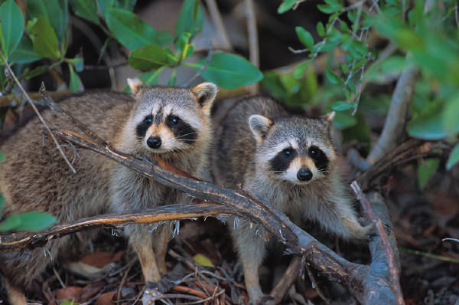 THEME: Animals

Selection Title | Focus Question(s)
Raccoons | What are baby raccoons called? What do raccoons eat?
Baby Animals | What kinds of baby animals have you seen before? Which baby animals look like their parents? Which baby animals do not look like their parents?
Munch Crunch: The Foods Animals Eat | Do all animals eat the same kinds of food? Which kinds of animals eat the same kinds of food as people?
Spiders | Why does a spider spin a web? How do spiders help people?
The Hermit Crab | Are all crabs alike? How does a hermit crab stay safe?

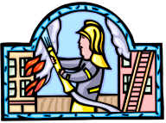 THEME: Our Neighborhood at Work

Selection Title | Focus Question(s)
Guess Who? | What job do you want to have when you get older? What kinds of work do people do in your neighborhood?
Worksong | How many people have you seen working today? What jobs do you think would be hard?

 THEME: Things That Go

Selection Title | Focus Question(s)
I Go With My Family to Grandma’s | When you visit people who live far away, how do you get there? How did people travel long ago?
Song on the Train | How do the trains move? What sounds do trains make?
On the Go | How do you move from place to place? How do people around the world move from place to place?
Trucks (Camiones) | How is truck different from a car? If you were a truck driver, what would you carry in your truck?

 THEME: Captain Bill Pinkney’s Journey

Selection Title | Focus Question(s)
Captain Bill Pinkney’s Journey | What is something that you dream of doing? What would you see on a trip around the world?

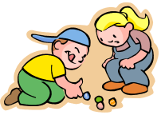 THEME: Games

Selection Title | Focus Question(s)
A Game Called Piggle | Have you and a friend ever made up your own game? What words rhyme with “piggle”?
Jafta | When you play make-believe games, what do you pretend to be? If you could be an animal, what animal would you be?
The Big Team Relay Race | What is the best thing about playing on a team with friends? If you are smaller than your teammates, can you still help your team?
Mary Mack | Do you know any hand-clapping games? Do games always have a winner?
Matthew and Tilly | What games do you play with your friends? Why do we sometimes not get along with friends when we play games?

 THEME: Keep Trying

Selection Title | Focus Question(s)
The Kite | Is it hard to keep trying when others tell you to give up? Is it easier to try if a friend is trying with you?
The Garden | If you try to grow a garden, what do seeds need to grow? How long does it take for a seed to grow?
74th Street | Have you ever gotten hurt when you tried something new? Did you keep trying?
The Way of an Ant | Have you learned something, and then decided to learn something more difficult? Have you helped someone younger than you learn something new?
The Fox and the Grapes | Will you always get what you want when you try hard? What if we try something and it doesn’t work out?
The Hare and the Tortoise | Does the fastest runner always win every race? Can you be successful if you work slowly?

 THEME: Being Afraid

Selection Title | Focus Question(s)
My Brother is Afraid of Just About Everything | What are some things you are afraid of? How could you help a friend overcome his or her fear?
Something is There | How do you feel when you are afraid? Have you ever heard something that made you afraid?
Strange Bumps | Why are people afraid of the dark sometimes? Have you ever thought you’ve seen something in the dark, and it was not really there?
Little Miss Muffet | Do you like spiders? Why or why not? What would you do if you saw a spider next to you?
Clyde Monster | What fears have you tried to get over? How did you do it?
The Cat and the Mice | Why would a mouse want to stay away from a cat? Do animals get scared sometimes?

 THEME: Homes

Selection Title | Focus Question(s)
Homes Around the World | Why are homes different? How do homes keep us safe?
Building a House | What kinds of workers help to build a house? What things do people use to build a house?
The Three Little Pigs | What materials would you use to build a house? Why would it be important for someone to make a plan before building a house?
Animal Homes | Do all animals live in the same kind of house? What animal homes have you seen?
Make a Home | How can you make a home for an animal? What would an animal need in or near its home?
Home for a Bunny | What time of year are many animals born? Could a bunny live in a bird’s home?
Is This a House for Hermit Crab? | Why would a hermit crab need to move to a different house? Where would be a good place for a hermit crab to live?
2nd Grade

 THEME: Sharing Stories

Selection Title | Focus Question(s)
Come Back, Jack! | Have you ever shared a story with someone younger? In what ways can books be exciting?
Story Hour – Starring Megan! | Can sharing stories with others make us better readers? Would you enjoy reading to other children during story hour at the library?
Ant and the Three Little Pigs | Have you ever shared a story that made someone laugh? Do you have a favorite story that you know of “by heart”?
Tomás and the Library Lady | Who can be a storyteller? Does your family tell or read stories to one another?
Amber on the Mountain | What are some different ways we can share stories? Have you ever made a friend by sharing a story?

 THEME: Kindness

Selection Title | Focus Question(s)
Mushroom in the Rain | Does kindness always make room for one more? Can we sometimes help more than we think we can?
The Elves and the Shoemaker | Is it better to give kindness or to receive it? How does being kind to others make you feel?
The Paper Crane | Why should we be kind to people in need? Should we be kind to strangers?
Corduroy | How can being kind help you make friends? Should kindness be determined by our outward appearances?
The Story of the Three Whales | How can kindness spread to others? Can kindness be a team effort?
Cinderella | Can reading stories teach us ways to be kind? How does jealousy keep us from being kind?

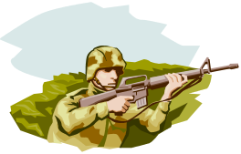 THEME: Look Again

Selection Title | Focus Question(s)
I See Animals Hiding | Why do animals need to hide? What does “there’s more to the animal world than meets the eye” mean?
Animal Camouflage | Why do animals camouflage themselves in different ways? How is camouflage like wearing a costume?
They Thought They Saw Him | How might you outsmart a predator? What does it mean to be “the color of the world”?
How the Guinea Fowl Got Her Spots | Do you think animals look out for each other? In what ways? Do animals have a system of warning to alert other animals of danger?

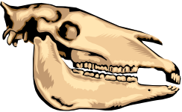 THEME: Fossils

Selection Title | Focus Question(s)
Dinosaur Fossils | How are fossils formed? Why are fossils important discoveries?
The Dinosaur Who Lived in My Backyard | What is the difference between fact and opinion? Is it possible that a dinosaur once lived in you backyard?
Why Did the Dinosaur Disappear? | Why aren’t scientists sure about what happened to the dinosaurs? What do you think happened to the dinosaurs?
Monster Tracks | Are fossils still being discovered today? Knowing how fossils are made, how would you make a fossil of your own?

 THEME: Courage

Selection Title | Focus Question(s)
Molly the Brave and Me | Can people be brave all of the time? How have you ever helped a friend to be brave?
Dragons and Giants | Do you feel braver when you are with a friend? Does saying you’re brave make you brave?
The Hole in the Hike | What does it mean to be a hero? Can anyone become a hero in a time of crisis?
A Picture Book of Martin Luther King, Jr. | Can a courageous leader encourage others to be courageous, too? Can there be dangers in taking a stand for what you believe in?
The Empty Pot | Why does it take courage to tell the truth? Does it take courage to admit failure?
Brave as a Mountain Lion | Why do we need to have courage to stand up to our fears? Have you ever had a fear of standing up in front of an audience? How did you overcome this fear?

 THEME: Our Country and Its People

Selection Title | Focus Question(s)
A Place Called Freedom | What does it mean to be free? Why is it difficult to move to a new place and start over?
The Story of the Statue of Liberty | How does the Statue of Liberty represent our country and its people? Why do you think the Statue of Liberty is a symbol of freedom to immigrants?
New Hope | What does it mean to have hope? How do you think towns and communities first got started in our country?
The Butterfly Seeds | Why do people want to hold on to their past after moving to a new land? What feelings would you have leaving your home country and the people you love?
A Very Important Day | Who are the immigrants in our country? Why is citizenship so important to immigrants?
Jalapeño Bagels | Are we alike because we all live in America? How do our differences make our country stronger?

3rd Grade

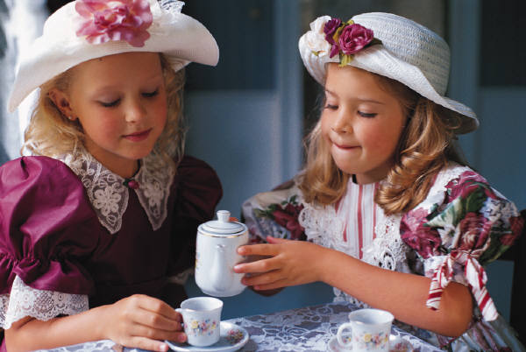 THEME: Friendship

Selection Title | Focus Question(s)
Gloria Who Might Be My Best Friend | What do you think it means to be a best friend? How have you made new friendships?
Angel Child, Dragon Child | What might it be like to be in a new school and in a new country? How would you make friends if you didn’t speak the same language as the rest of your classmates?
The Tree House | What is it like to have a friend be mean to you? How can you make up with a friend when you realize the friendship is more important than whatever caused the fight?
Teammates | Why must we sometimes show courage in order to keep a friend? Why is working together toward a common goal important to friendships?

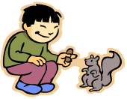 THEME: City Wildlife

Selection Title | Focus Question(s)
City Critters: Wild Animals Live in Cities, Too | What can scientists learn about a city when they study its wildlife? How can city communities help protect their wildlife?
City Lots: Living Things in Vacant Spots | How important are open spaces in a city? What makes a city a good place to live for some wildlife?
The Boy Who Didn’t Believe in Spring | What is city wildlife? What types of wildlife would you expect to find in a city?
Urban Roosts: Where Birds Nest in the City | Many different species of birds survive in busy cities. How do you think this is possible? Do you think that people or wildlife adapt more easily to their environments? Why?
Make Way for Ducklings | How can an environment be both safe and dangerous for its wildlife? How do various types of city wildlife adapt to their environments? What role do people play in protecting the natural environment?

 THEME: Imagination

Selection Title | Focus Question(s)
Through Grandpa’s Eyes | What are the five senses? How do you think losing one of the senses might affect the others?
The Cat Who Became a Poet | How can using your imagination help you see things in a new way? How can your life be more exciting and rewarding when you use your imagination?
Picasso | How can you turn something from your imagination into something that others can see, hear, touch, or taste? Have you ever created an object from your imagination? If so, explain. If not, what would you like to create?
Roxaboxen | Have you ever imagined that the playground, your backyard, or your bedroom is a different place? What places do you imagine they are? What do you do in your imaginary worlds?

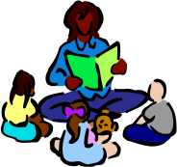 THEME: Storytelling

Selection Title | Focus Question(s)
A Story A Story | What would you be willing to give up in order to have all of the stories in the world? In what ways can you possess stories without having to give up very much?
Carving the Pole | If you were not able to write a story using words, how would you go about telling your story? What methods could you use to make your stories memorable?
Oral History | What do you think oral history means? Why is storytelling an important tradition?
Aunt Flossie’s Hats (and Crab Cakes Later) | Do you own something that holds a special memory for you? How do you share your special memories? With whom do you share your special memories?
The Keeping Quilt | What item from you family represents something of you family’s past or of your family’s traditions? How do you think your family has changed over the years? How do family stories help you remember the changes?

 THEME: Money

Selection Title | Focus Question(s)
A New Coat for Anna | Why do we sometimes have to give up something we have in order to get something we want? Why are things we receive more special when others have had to work together in order to give them to us?
Kids Did It! In Business | What would it be like to own your own business? What do you think you would need to start a business? What characteristics are important in running a successful business?
Alexander: Who Used to Be Rich Last Sunday | How do you decide how to spend your money? Why is it more important to make wise decisions when spending money?
Four Dollars and Fifty Cents | What does it mean to be in debt? Why is it so important to pay back debts?
The Cobbler’s Song | How can people have happy and meaningful lives without a great deal of money? Why would money have a greater value if it is well earned?

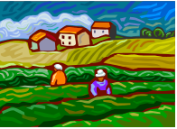 THEME: Country Life

Selection Title | Focus Question(s)
Heartland | Why is the Midwestern farmland of America called the Heartland? Why is the Heartland such an important part of America? Why would it take the energy of both humans and machinery to develop farmland?
Cows in the Parlor: A Visit to a Dairy Farm | What would it be like to live and work on a farm? How has modern machinery affected life on a farm?
Just Plain Fancy | Why is it sometimes difficult to follow the rules? Although rules are important, sometimes there are good reasons for breaking the rules. What might some of these good reasons be?
What Ever Happened to the Baxter Place? | Compare the advantages of small, family farms to big, company farms. What are some of the disadvantages? How can small farms compete with big farms?
The Country Mouse and the City Mouse | Would you prefer to live in the country or in the city? What are some of the differences between living in the country and living in the city?

4th Grade

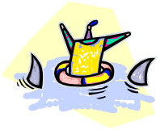 THEME: Risks and Consequences

Selection Title | Focus Question(s)
Mrs. Frisby and the Crow | Are there times when we must take a risk to help others? Can our own risks sometimes endanger others?
Toto | When is a risk worth taking? How can concern for others help us to overcome our own fears?
Sarah, Plain and Tall | Can it be risky to make new friends? What would make you risk leaving a place you love?
Mae Jemison: Space Scientist | What would the world be like if no one ever took a risk? Can you fulfill your dreams without taking some risks?
Two Tickets to Freedom | Is it sometimes riskier to do nothing? What is important enough to you to make you risk your life?

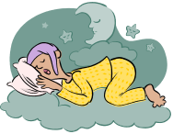 THEME: Dreams to Jobs

Selection Title | Focus Question(s)
Elias Sifuentes, Restauranteur | What makes a business successful? Does everyone have what it takes to run a business?
Food From the ‘Hood: A Garden of Hope | Are profits always the most important thing to a business? What business can you think of that could help your community?
Business is Looking Up | How do people get their ideas for new businesses? What are some things to think about before starting a business?
Salt | How does a business build up a market? What role does luck play in business success?

 THEME: From Mystery to Medicine

Selection Title | Focus Question(s)
Medicine: Past and Present | How do doctors know what makes us sick? Why can’t doctors cure all the diseases in the world?
Sewed Up His Heart | How do doctors decide when to operate? Do doctors ever get scared?
The Bridge Dancers | How do people know which plants are medicinal? What would you do if your friend got badly hurt, and you were the only one around?
The New Doctor | How does medicine differ from place to place? What are the most important qualities in a doctor?
The Story of Susan La Flesche | What makes some people decide to be doctors? How do doctors feel when they cannot help a patient get better?
Shadow of a Bull | What would it be like if there were no doctors? How can doctors stay calm when someone is in great pain?

 THEME: Surviving

Selection Title | Focus Question(s)
Island of the Blue Dolphins | What basic needs must be met for people to survive? Why do some people try harder than others to survive?
Artic Explorer: The Story of Matthew Henson | What makes it easier to survive in some places than in others? What steps would take to survive in the Arctic?
McBroom and the Big Wind | What are some things you can do to prepare for a natural disaster? Have you ever been frightened by the weather?
The Big Wave | What part does luck play in surviving a disaster? Why do disasters have to happen?
Anne Frank: The Diary of a Young Girl | Why do some people risk their own safety to help others survive? What can we learn from people who have survived terrible events?
Music and Slavery | Can people make a difficult situation easier to survive? How do survivors pass on their stories to others?

 THEME: Communication

Selection Title | Focus Question(s)
Breaking into Print | How did the printing press change the way people communicate? How would your life be different if there were no books?
Koko’s Kitten | Could all animals learn to communicate with people? What would you ask Koko if you had the chance to communicate with her?
Louis Braille: The Boy Who Invented Books for the Blind | Why is written communication so important to society? Have you ever tried to learn a new form of communication?

 THEME: Trail of Freedom

Selection Title | Focus Question(s)
Early America | Would you have liked to be one of the first people to colonize America? Why did the Native Americans help the first colonists?
The Voyage of the Mayflower | Why would people take such a risky journey to go live in America? Were the children aboard the Mayflower very different from children now?
Pocahontas | What was it like for the Native Americans to see the colonists arriving? Can we call Pocahontas a “colonist”?
Martha Helps the Rebel | Were all the colonists in favor of the Revolution? Could the colonies have broken from England without a war?

5th Grade

 THEME: Cooperation and Competition

Selection Title | Focus Question(s)
Class President | What qualities do good leaders have? If you were running for class president, what would be your strategy for winning the election?
The Marble Champ | What enables Lupe to accomplish her goals? Must one have natural ability in order to become good at something?
Juggling | What does “juggling” have to do with cooperation? What important lesson does Kyle learn by the end of the story?
The Abacus Contest | Why is Gao Mai nervous about the upcoming abacus contest? Is it possible to be friends with one’s rival?
S.O.R. Losers | Should one always try to be a winner? Is it ever better to lose a competition than to win one?

 THEME: Back Through the Stars

Selection Title | Focus Question(s)
Galileo | How did Galileo contribute to what we know about our solar system? How did people react to his discoveries?
Telescopes | What is the difference between refracting and reflecting telescopes? Why were radio telescopes created? How will the Hubble space telescope change astronomy?
The Heavenly Zoo | How did some constellations get their names? What do these myths tell about the values and beliefs of the people who created them?
Circles, Squares, and Daggers: How Native Americans Watched the Sky | How and why did Native Americans study the skies? What do Native American observations tell us about how these people lived and adjusted to their natural environment?
Stars | How are stars created? What are some of the different types of stars? Are there other galaxies like ours in the universe?
The Book That Saved the Earth | What about humans might beings from other planets find strange? How might they react to objects that are ordinary to humans?

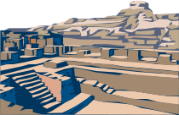 THEME: Heritage
Selection Title | Focus Question(s)
The Land I Lost: Adventures of a Boy in Vietnam | What memories does the author carry with him of his boyhood in Vietnam? Why are these memories important to him?
In Two Worlds: A Yup’ik Eskimo Family | What was life like for the Yup’ik Eskimos of long ago? What is life like for them in the present day? Why do the Yup’iks continue to teach their children the old ways?
The West Side | Why does Juan feel at home in New York City? What might make Juan feel better about living in the United States?
The Night Journey | Why is the samovar so important to Nana Sashie? Why does Rache want to know the story of her grandmother’s girlhood?
Parmele | Why do you think the author’s trips to Parmele were meaningful? Why do you think the town was so important to her grandfather?

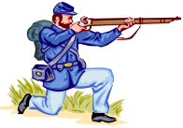 THEME: The Civil War
Selection Title | Focus Question(s)
 | There are no focus questions for this unit.

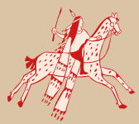 THEME: New Frontier
Selection Title | Focus Question(s)
Buffalo Hunt | In what ways were the buffalo important to the Native Americans of the Great Plains? How did the building of the Transcontinental Railroad affect the buffalo?
The Coming of the Long Knives | What are the characteristics of the Navaho settlement in this story? How do the soldiers force the Navaho to leave the canyon?
Old Yeller and the Bear | What kinds of animals does Arliss encounter on the frontier? How does he get himself into trouble with the bear? Who will rescue Arliss?
Bill Pickett: Rodeo-Ridin’ Cowby | How did Bill Pickett’s family come to live on the Texas plains? What skills did Bill learn by working on the ranch? For what rodeo stunt was Bill famous?
McBroom and the Rainmaker | How does McBroom plan to create a rainstorm? Why do you think this type of story was popular with frontier people?

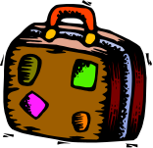 THEME: Journeys and Quests
Selection Title | Focus Question(s)
The Story of Jumping Mouse | Where does Jumping Mouse want to go? Will he be able to reach his destination? What character trait helps him most on his journey?
Sacagawea’s Journey | Why did Lewis and Clark explore the West? How was Sacagawea important to the expedition? What were her reasons for making the trip?
When Shlemiel Went to Warsaw | Why does Shlemiel embark on his journey? How far does he go? What do Shlemiel’s travels change for him?
The Search | What does Miguel think he will earn by finding the sheep? How does Miguel’s search become an inner journey? What does he prove to himself?
Alberic the Wise | What inspires Alberic to leave his home? How does he become wise? What is his greatest discovery?

